TG-51 Worksheet C: Kecal N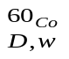for plane-parallel chambers

There are two methods for determining Kecal N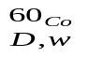 for plane-parallel chamber. Method A uses cross - calibration against a calibrated cylindrical chamber and is preferred method. Method B uses a ⁶⁰Co absorbed-dose calibration factor.

Method A: Cross-Calibration
- Site data

Institution:

Physicist:

Date:

Accel Mfr.:

Model & serial number:
Nominal e⁻ energy/beam identifier: MeV

2. Dose using cylindrical chamber
Do reference dosimetry for this beam using Worksheet B.
Transfer the following information from that worksheet:
a. Date: [B:1]
b. Beam quality R₅₀: [B:4a]
c. Reference depth, d_{ref} [B:4b]
d. Dose/MU at d_{ref}: [B:10c]
e. Number of MU (same used here): [B:3c]

Now place the point of measurement of the plane-parallel chamber at d_{ref}

- Temperature/ Pressure Correction (Sec. VII. C)
a. Temperature: °C
b. Pressure: 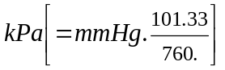
c. P_{Tp}: 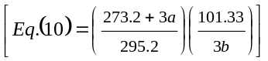
- Polarity Correction (Sec. VII. A.)
M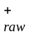: C or rdg
M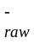: C or rdg
a. M_{raw} (for polarity used clinically): C or rdg
b.P_{pol}: 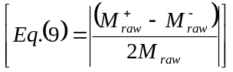
5. P_{ion} measurements (Sec. VII. D.2)
Operating Voltage = V_{H}: V
Lower voltage V_{L}: V
M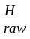: C or rdg
M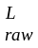: C or rdg
P_{ion} (V_{H}) (pulsed/swept beam, Eq.(12)): 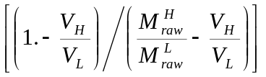
If P_{ion}> 1.05, another ion chamber should be used.
TG-51 Worksheet C: Kecal Nfor plane-parallel chambers (cont)

- Corrected ion. Ch. Rdg. M (Sec. VII)

Fully corrected M(Eq.(8)): C or rdg

- Determination of 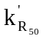for plane-parallel chamber, beam quality R₅₀(2b)
i. from figures [Fig 6 or 8]
or ii. from analytic expression for well-guarded plane-parallel chambers
= 1.2239 – 0.145(R₅₀)^{0.214} [Eq.(20) 2≤ R₅₀ ≤ 20 cm]
- Cross calibration value
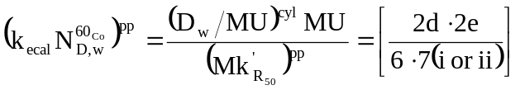
Gy/C(or Gy/rdg)

Method B: ⁶⁰Co Calibration

- Instrumentation
a. Chamber model:
Serial number:

Waterproof: yes no

If no, is waterproofing ≤ 1 mm PMMA or thin latex?: yes no

b. Electrometer model:
Serial number:
i. P_{elec}, electrom. Corr factor (Sec. VII. B): C/C or C/rdg.
c. Calibration Factor 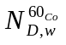(Sec. V): Gy/C (or Gy/rdg
Date of report (not to exceed 2 years):
2. Determination of k_{ecal}
Chamber model used to get k_{ecal}:
a. k_{ecal}: [Table II]

3. 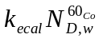:
Gy/C(orGy/rdg)

